BSC – HGP - Assignment 02

Pictionary Game

UI Design Document

___________________________________________________________________________________

**Student Name:** GENTHON Lou-John

**Student Number: 3099142**

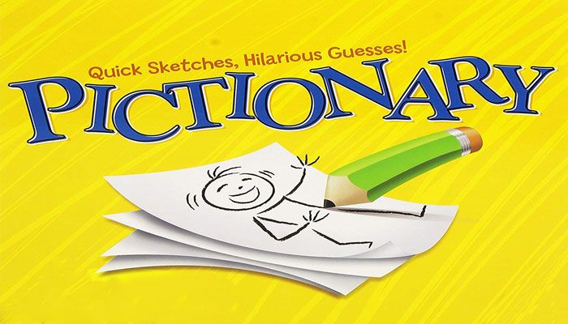

# **General appearance of the application:**

My work: My reference (Gartic phone):

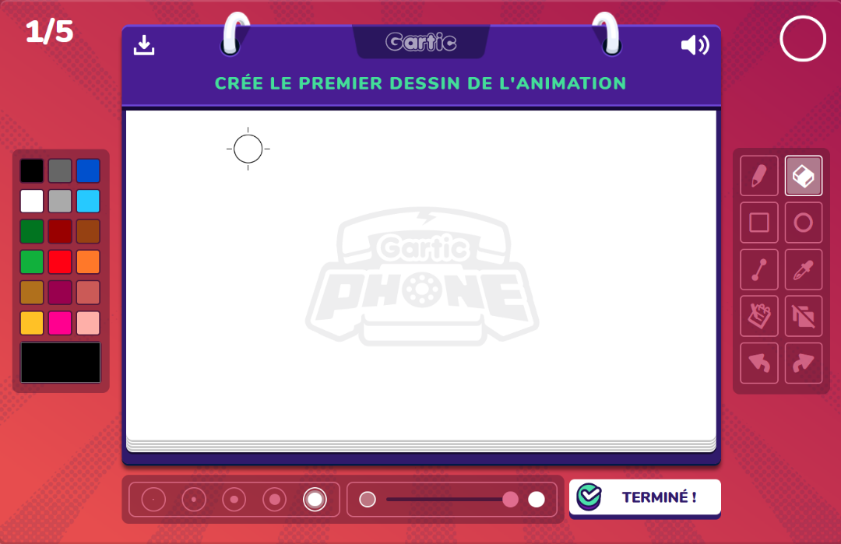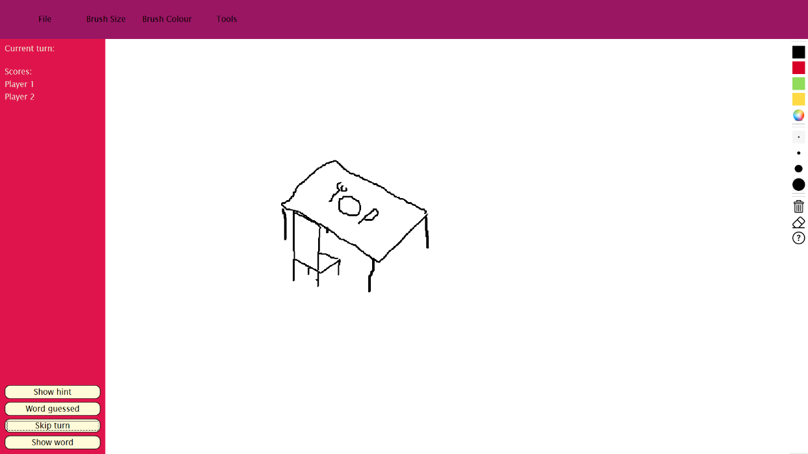

My main inspiration for my UI is Gartic Phone, a game very similar to Pictionary and that is played online.  
The game is dynamic, so every tool and functionality should be easily accessible for a smooth experience.

As such, the toolbar on the right displays most of the actions that can be taken by the user with clear, recognizable icons.

The main part of the screen is taken up by the white paper as it is the place the user will interact with most.  
I chose this color palette in particular because red is a color that elicits a dominant emotional and behavioral response, as it is said by Mentzelin, Emotionality of Colors: An Implicit Link between Red and Dominance (2017). The user will be more engaged in the game and consequently, have more fun.

**Functionalities:**

Menu:

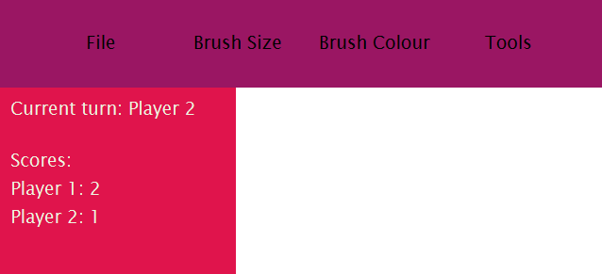

This menu is situated in the corner, and it contains most of the data that is valuable to the user.

There are all the tools available to him in the dropdown menus (changing color, changing pen size, clearing the page etc…), and the actual game state is also available here (turn of the player and scores).

It is placed in the top right corner because it is the first place where the user will look and it is the same menu disposition as most big applications (like Word), the experience of the user is used to make the UI easier for him to understand.

The “tools” menu contains useful information for the players, like the rules in “Help” which opens a pop-up explaining everything for the game to run smoothly.

All the buttons that permit user interaction with how the game unrolls are situated on the b bottom left. This is the place where to look at even before starting to draw as the “Show word” button is capital to the player.

**Extra features:**

Toolbar:

This toolbar situated at the right of the page contains almost every action that would be present in the menus. The information in the menus is clearer, but they are easier of access here. The user can quickly switch between brush sizes and colors, the eraser or even erasing the whole page.

The smoothness of the game and the user experience can only be greater when the tools are easy of access and work properly

Hint button:

If the guessing player really needs some help, the “Show hint” button is available. A pop-up will be displayed with the first letter of the random word and the length of the word to give a better idea of what it could be. The guessing player will receive one less point when he guesses the word if he uses the hint, so he needs to be careful.

Player name input:

A name input pop-up is displayed as soon as the game is started. The two players can then input their names and they will be displayed next to the score and in the informative pop-ups. This makes the app more customizable, and the user will be able to comprehend the information that would beforehand be more basic (“player 1”) more easily.

Color wheel:

I implemented a color wheel in the “brush color” dropdown menu as it is a good tool that grants the user access to whichever color he wants to use. It is very handy as implementing hundreds of colors would be convenient neither for the player nor the developer.

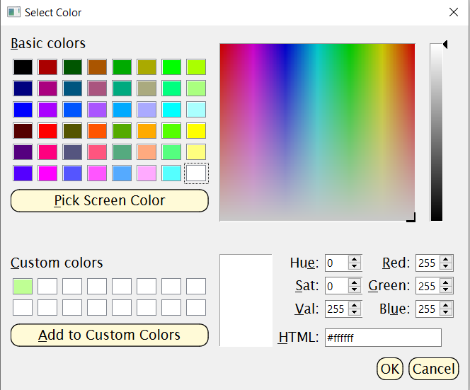

Timer (doesn’t work):

Using threads, I tried to code in a timer that would slowly countdown. The goal was to make the app able to make actions without the user’s input. For example, if the time counts down to 30, show the hint, and when it goes to 0 skip the player’s turn.

I was able to implement the timer but had problems with data sharing between the main thread and my timer thread. As it made my program crash when the shared data was used by multiple threads as the same time (which I understand is normal) I commented out this part in my code. I intend to keep working on it because I think it would be a valuable asset in another project. I will ask Professor Osama Abushama for some help on the threads as I am currently stuck.

**References :**

Mentzel, S.V., Schücker, L., Hagemann, N. and Strauss, B. (2017). Emotionality of Colors: An Implicit Link between Red and Dominance. Frontiers in Psychology, 8. doi:10.3389/fpsyg.2017.00317.